weights = [1.5, 0.3, 1.0]

1 run...

<tqdm.auto.tqdm object at 0x7f5ccc5a1e50>

<tqdm.auto.tqdm object at 0x7f5cd4ad1390>

training 1 epoch...

240.4415147304535 seconds used......

1 training finished! average train loss: 0.5796517314343097

evaluating...

Confusion matrix, without normalization

[[ 877 79 66]

[1707 3638 62]

[2880 221 7664]]

Normalized confusion matrix

[[0.85812133 0.07729941 0.06457926]

[0.31570187 0.67283151 0.01146662]

[0.26753367 0.02052949 0.71193683]]

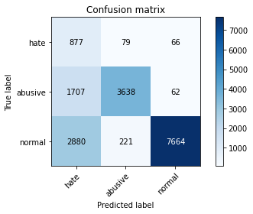

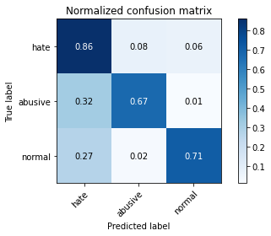

precision recall f1-score support

hate 0.16 0.86 0.27 1022

abusive 0.92 0.67 0.78 5407

normal 0.98 0.71 0.83 10765

accuracy 0.71 17194

macro avg 0.69 0.75 0.63 17194

weighted avg 0.92 0.71 0.78 17194

average eval_loss: 0.7016099584310553, accuracy: 0.7083284866814005

training 2 epoch...

239.57992672920227 seconds used......

2 training finished! average train loss: 0.41155152436572867

evaluating...

Confusion matrix, without normalization

[[ 835 59 128]

[2075 3191 141]

[1789 174 8802]]

Normalized confusion matrix

[[0.81702544 0.05772994 0.12524462]

[0.38376179 0.5901609 0.02607731]

[0.16618672 0.01616349 0.81764979]]

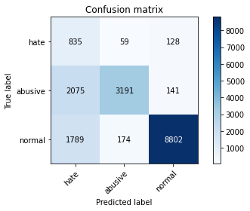

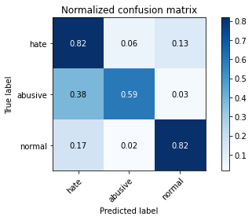

precision recall f1-score support

hate 0.18 0.82 0.29 1022

abusive 0.93 0.59 0.72 5407

normal 0.97 0.82 0.89 10765

accuracy 0.75 17194

macro avg 0.69 0.74 0.63 17194

weighted avg 0.91 0.75 0.80 17194

average eval_loss: 0.5688760848932488, accuracy: 0.7460742119343957

training 3 epoch...

239.68882536888123 seconds used......

3 training finished! average train loss: 0.28617255596557534

evaluating...

Confusion matrix, without normalization

[[ 752 111 159]

[1476 3755 176]

[1314 253 9198]]

Normalized confusion matrix

[[0.73581213 0.10861057 0.1555773 ]

[0.27297947 0.69447013 0.0325504 ]

[0.12206224 0.02350209 0.85443567]]

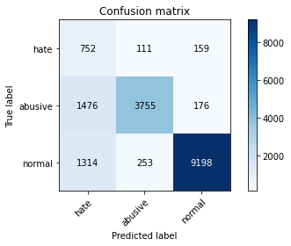

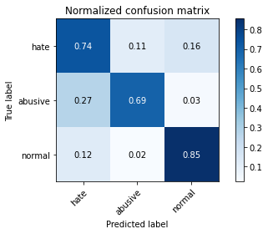

precision recall f1-score support

hate 0.21 0.74 0.33 1022

abusive 0.91 0.69 0.79 5407

normal 0.96 0.85 0.91 10765

accuracy 0.80 17194

macro avg 0.70 0.76 0.67 17194

weighted avg 0.90 0.80 0.83 17194

average eval_loss: 0.5046156842608092, accuracy: 0.7970803768756543

training 4 epoch...

239.63689351081848 seconds used......

4 training finished! average train loss: 0.17853864876481937

evaluating...

Confusion matrix, without normalization

[[ 767 125 130]

[1431 3865 111]

[1772 407 8586]]

Normalized confusion matrix

[[0.75048924 0.1223092 0.12720157]

[0.26465693 0.71481413 0.02052894]

[0.16460752 0.03780771 0.79758477]]

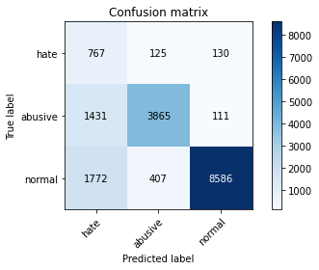

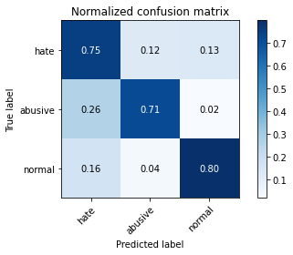

precision recall f1-score support

hate 0.19 0.75 0.31 1022

abusive 0.88 0.71 0.79 5407

normal 0.97 0.80 0.88 10765

accuracy 0.77 17194

macro avg 0.68 0.75 0.66 17194

weighted avg 0.90 0.77 0.81 17194

average eval_loss: 0.774796214054317, accuracy: 0.7687565429801093

training 5 epoch...

239.85446333885193 seconds used......

5 training finished! average train loss: 0.13580500298762024

evaluating...

Confusion matrix, without normalization

[[ 789 92 141]

[1786 3450 171]

[1629 249 8887]]

Normalized confusion matrix

[[0.77201566 0.09001957 0.13796477]

[0.33031256 0.63806177 0.03162567]

[0.15132373 0.02313052 0.82554575]]

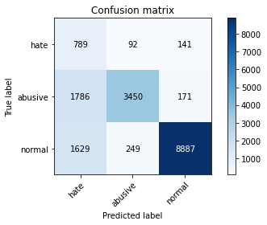

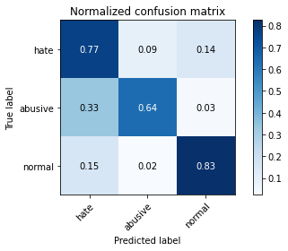

precision recall f1-score support

hate 0.19 0.77 0.30 1022

abusive 0.91 0.64 0.75 5407

normal 0.97 0.83 0.89 10765

accuracy 0.76 17194

macro avg 0.69 0.75 0.65 17194

weighted avg 0.90 0.76 0.81 17194

average eval_loss: 0.7762690707716311, accuracy: 0.7634058392462487

2 run...

training 1 epoch...

240.0016098022461 seconds used......

1 training finished! average train loss: 0.5914941575403407

evaluating...

Confusion matrix, without normalization

[[ 864 59 99]

[1962 3339 106]

[1881 169 8715]]

Normalized confusion matrix

[[0.84540117 0.05772994 0.09686888]

[0.36286296 0.61753283 0.01960422]

[0.17473293 0.01569902 0.80956804]]

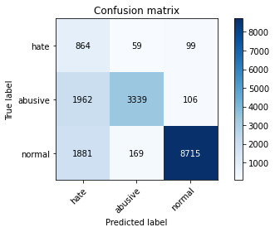

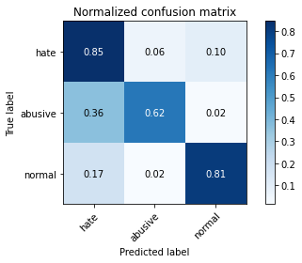

precision recall f1-score support

hate 0.18 0.85 0.30 1022

abusive 0.94 0.62 0.74 5407

normal 0.98 0.81 0.89 10765

accuracy 0.75 17194

macro avg 0.70 0.76 0.64 17194

weighted avg 0.92 0.75 0.81 17194

average eval_loss: 0.5523671631896219, accuracy: 0.7513085960218681

training 2 epoch...

239.86765933036804 seconds used......

2 training finished! average train loss: 0.4190338638108686

evaluating...

Confusion matrix, without normalization

[[ 854 68 100]

[1835 3473 99]

[2097 195 8473]]

Normalized confusion matrix

[[0.83561644 0.0665362 0.09784736]

[0.33937488 0.64231552 0.0183096 ]

[0.19479796 0.01811426 0.78708778]]

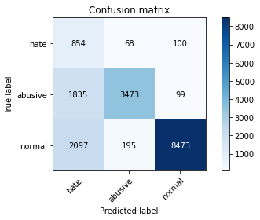

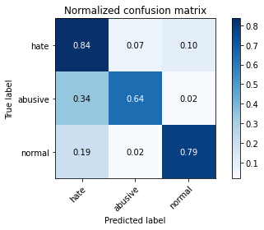

precision recall f1-score support

hate 0.18 0.84 0.29 1022

abusive 0.93 0.64 0.76 5407

normal 0.98 0.79 0.87 10765

accuracy 0.74 17194

macro avg 0.70 0.76 0.64 17194

weighted avg 0.91 0.74 0.80 17194

average eval_loss: 0.5864918766499951, accuracy: 0.7444457368849599

training 3 epoch...

240.02705121040344 seconds used......

3 training finished! average train loss: 0.29991445364956126

evaluating...

Confusion matrix, without normalization

[[ 828 65 129]

[1852 3400 155]

[1659 189 8917]]

Normalized confusion matrix

[[0.81017613 0.06360078 0.12622309]

[0.34251896 0.6288145 0.02866654]

[0.15411054 0.0175569 0.82833256]]

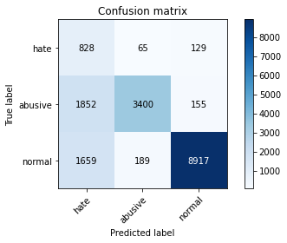

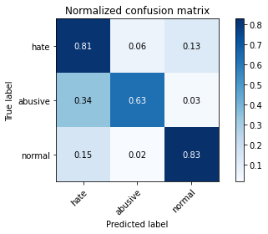

precision recall f1-score support

hate 0.19 0.81 0.31 1022

abusive 0.93 0.63 0.75 5407

normal 0.97 0.83 0.89 10765

accuracy 0.76 17194

macro avg 0.70 0.76 0.65 17194

weighted avg 0.91 0.76 0.81 17194

average eval_loss: 0.5878034321461306, accuracy: 0.7645108758869373

training 4 epoch...

239.8692924976349 seconds used......

4 training finished! average train loss: 0.19472939397038105

evaluating...

Confusion matrix, without normalization

[[ 839 67 116]

[1893 3357 157]

[2078 225 8462]]

Normalized confusion matrix

[[0.82093933 0.06555773 0.11350294]

[0.35010172 0.62086185 0.02903643]

[0.19303298 0.02090107 0.78606595]]

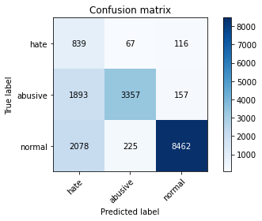

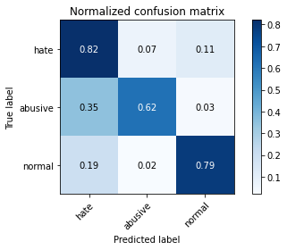

precision recall f1-score support

hate 0.17 0.82 0.29 1022

abusive 0.92 0.62 0.74 5407

normal 0.97 0.79 0.87 10765

accuracy 0.74 17194

macro avg 0.69 0.74 0.63 17194

weighted avg 0.91 0.74 0.79 17194

average eval_loss: 0.8295437133069649, accuracy: 0.7361870419913924

training 5 epoch...

240.0823872089386 seconds used......

5 training finished! average train loss: 0.14746047203632967

evaluating...

Confusion matrix, without normalization

[[ 763 110 149]

[1365 3856 186]

[1558 255 8952]]

Normalized confusion matrix

[[0.74657534 0.10763209 0.14579256]

[0.25245053 0.71314962 0.03439985]

[0.14472829 0.02368788 0.83158384]]

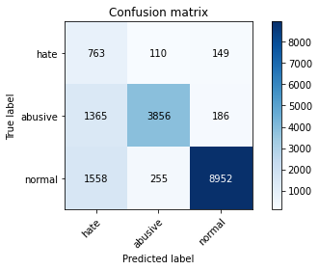

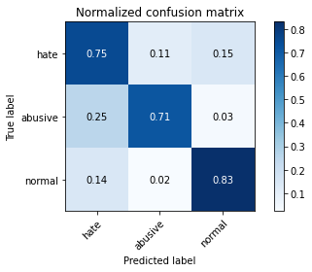

precision recall f1-score support

hate 0.21 0.75 0.32 1022

abusive 0.91 0.71 0.80 5407

normal 0.96 0.83 0.89 10765

accuracy 0.79 17194

macro avg 0.69 0.76 0.67 17194

weighted avg 0.90 0.79 0.83 17194

average eval_loss: 0.7122918078383474, accuracy: 0.7892869605676399

3 run...

training 1 epoch...

240.09303545951843 seconds used......

1 training finished! average train loss: 0.5837944745681086

evaluating...

Confusion matrix, without normalization

[[ 846 66 110]

[2014 3282 111]

[1827 175 8763]]

Normalized confusion matrix

[[0.82778865 0.06457926 0.10763209]

[0.37248012 0.60699094 0.02052894]

[0.16971667 0.01625639 0.81402694]]

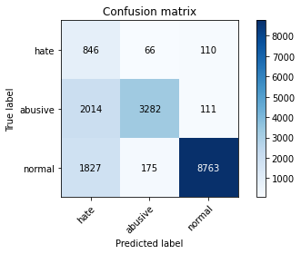

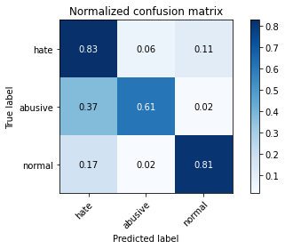

precision recall f1-score support

hate 0.18 0.83 0.30 1022

abusive 0.93 0.61 0.74 5407

normal 0.98 0.81 0.89 10765

accuracy 0.75 17194

macro avg 0.70 0.75 0.64 17194

weighted avg 0.91 0.75 0.80 17194

average eval_loss: 0.546218382636475, accuracy: 0.7497382807956264

training 2 epoch...

240.1191611289978 seconds used......

2 training finished! average train loss: 0.41711333589144806

evaluating...

Confusion matrix, without normalization

[[ 856 63 103]

[1951 3334 122]

[2072 180 8513]]

Normalized confusion matrix

[[0.83757339 0.06164384 0.10078278]

[0.36082856 0.6166081 0.02256334]

[0.19247562 0.01672085 0.79080353]]

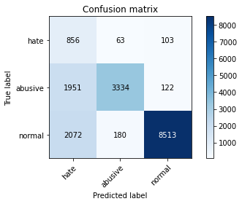

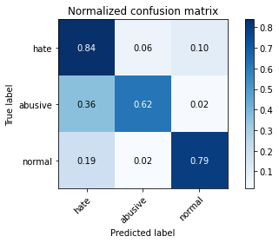

precision recall f1-score support

hate 0.18 0.84 0.29 1022

abusive 0.93 0.62 0.74 5407

normal 0.97 0.79 0.87 10765

accuracy 0.74 17194

macro avg 0.69 0.75 0.64 17194

weighted avg 0.91 0.74 0.80 17194

average eval_loss: 0.5844168393071307, accuracy: 0.7388042340351285

training 3 epoch...

240.18466091156006 seconds used......

3 training finished! average train loss: 0.2883559519353556

evaluating...

Confusion matrix, without normalization

[[ 773 79 170]

[1695 3411 301]

[1368 165 9232]]

Normalized confusion matrix

[[0.75636008 0.07729941 0.16634051]

[0.31348252 0.6308489 0.05566858]

[0.1270785 0.01532745 0.85759405]]

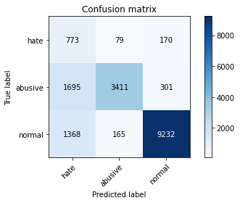

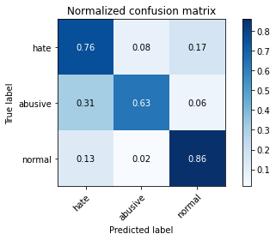

precision recall f1-score support

hate 0.20 0.76 0.32 1022

abusive 0.93 0.63 0.75 5407

normal 0.95 0.86 0.90 10765

accuracy 0.78 17194

macro avg 0.70 0.75 0.66 17194

weighted avg 0.90 0.78 0.82 17194

average eval_loss: 0.5064866103751715, accuracy: 0.7802721879725486

training 4 epoch...

239.9270749092102 seconds used......

4 training finished! average train loss: 0.18714911885492286

evaluating...

Confusion matrix, without normalization

[[ 802 95 125]

[1597 3640 170]

[1765 214 8786]]

Normalized confusion matrix

[[0.78473581 0.09295499 0.1223092 ]

[0.29535787 0.67320141 0.03144072]

[0.16395727 0.01987924 0.81616349]]

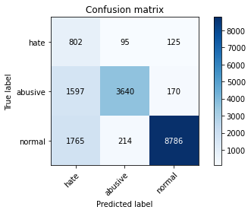

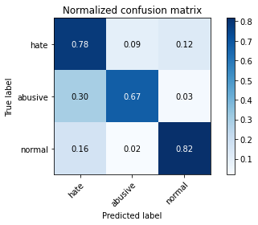

precision recall f1-score support

hate 0.19 0.78 0.31 1022

abusive 0.92 0.67 0.78 5407

normal 0.97 0.82 0.89 10765

accuracy 0.77 17194

macro avg 0.69 0.76 0.66 17194

weighted avg 0.91 0.77 0.82 17194

average eval_loss: 0.7605502574466342, accuracy: 0.7693381412120507

training 5 epoch...

239.90776681900024 seconds used......

5 training finished! average train loss: 0.13425703818907722

evaluating...

Confusion matrix, without normalization

[[ 749 108 165]

[1417 3788 202]

[1497 223 9045]]

Normalized confusion matrix

[[0.73287671 0.10567515 0.16144814]

[0.26206769 0.70057333 0.03735898]

[0.13906177 0.02071528 0.84022294]]

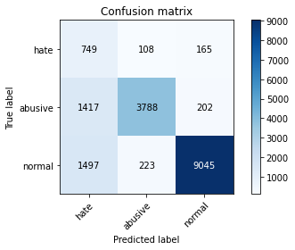

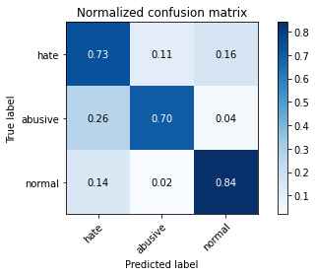

precision recall f1-score support

hate 0.20 0.73 0.32 1022

abusive 0.92 0.70 0.80 5407

normal 0.96 0.84 0.90 10765

accuracy 0.79 17194

macro avg 0.70 0.76 0.67 17194

weighted avg 0.90 0.79 0.83 17194

average eval_loss: 0.7005374981696869, accuracy: 0.7899267186227754

4 run...

training 1 epoch...

239.99752044677734 seconds used......

1 training finished! average train loss: 0.5854968456530409

evaluating...

4 run...

training 1 epoch...

239.99752044677734 seconds used......

1 training finished! average train loss: 0.5854968456530409

evaluating...

Confusion matrix, without normalization

[[ 861 69 92]

[1978 3333 96]

[2170 196 8399]]

Normalized confusion matrix

[[0.84246575 0.06751468 0.09001957]

[0.36582208 0.61642316 0.01775476]

[0.20157919 0.01820715 0.78021366]]

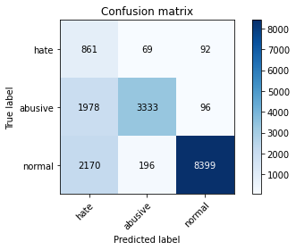

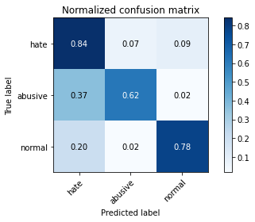

precision recall f1-score support

hate 0.17 0.84 0.29 1022

abusive 0.93 0.62 0.74 5407

normal 0.98 0.78 0.87 10765

accuracy 0.73 17194

macro avg 0.69 0.75 0.63 17194

weighted avg 0.91 0.73 0.79 17194

average eval_loss: 0.591923739795768, accuracy: 0.7324066534837734

training 2 epoch...

240.20806312561035 seconds used......

2 training finished! average train loss: 0.40677143877233396

evaluating...

Confusion matrix, without normalization

[[ 818 60 144]

[2024 3227 156]

[1331 179 9255]]

Normalized confusion matrix

[[0.80039139 0.05870841 0.1409002 ]

[0.37432957 0.59681894 0.02885149]

[0.12364143 0.01662796 0.85973061]]

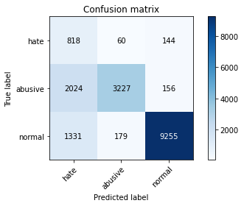

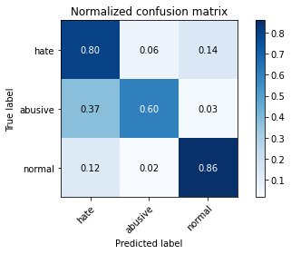

precision recall f1-score support

hate 0.20 0.80 0.31 1022

abusive 0.93 0.60 0.73 5407

normal 0.97 0.86 0.91 10765

accuracy 0.77 17194

macro avg 0.70 0.75 0.65 17194

weighted avg 0.91 0.77 0.82 17194

average eval_loss: 0.4884997085689805, accuracy: 0.7735256484820286

training 3 epoch...

240.1488902568817 seconds used......

3 training finished! average train loss: 0.27781048705528066

evaluating...

Confusion matrix, without normalization

[[ 790 77 155]

[1698 3540 169]

[1434 193 9138]]

Normalized confusion matrix

[[0.77299413 0.07534247 0.15166341]

[0.31403736 0.65470686 0.03125578]

[0.13320948 0.01792847 0.84886205]]

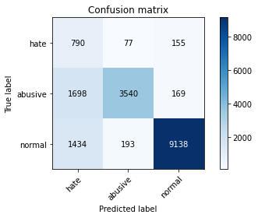

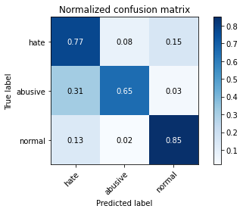

precision recall f1-score support

hate 0.20 0.77 0.32 1022

abusive 0.93 0.65 0.77 5407

normal 0.97 0.85 0.90 10765

accuracy 0.78 17194

macro avg 0.70 0.76 0.66 17194

weighted avg 0.91 0.78 0.83 17194

average eval_loss: 0.532321434645632, accuracy: 0.7832964987786437

training 4 epoch...

240.20645880699158 seconds used......

4 training finished! average train loss: 0.18064270793348888

evaluating...

Confusion matrix, without normalization

[[ 740 126 156]

[1430 3773 204]

[1549 225 8991]]

Normalized confusion matrix

[[0.72407045 0.12328767 0.15264188]

[0.26447198 0.69779915 0.03772887]

[0.14389224 0.02090107 0.83520669]]

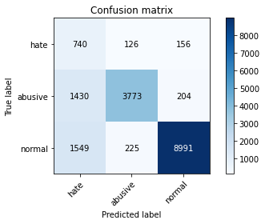

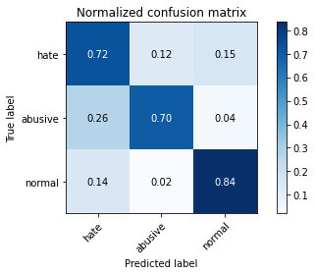

precision recall f1-score support

hate 0.20 0.72 0.31 1022

abusive 0.91 0.70 0.79 5407

normal 0.96 0.84 0.89 10765

accuracy 0.79 17194

macro avg 0.69 0.75 0.67 17194

weighted avg 0.90 0.79 0.83 17194

average eval_loss: 0.6137699428469289, accuracy: 0.7853902524136327

training 5 epoch...

240.1141858100891 seconds used......

5 training finished! average train loss: 0.13387678984266707

evaluating...

Confusion matrix, without normalization

[[ 755 141 126]

[1363 3885 159]

[1918 285 8562]]

Normalized confusion matrix

[[0.73874755 0.13796477 0.12328767]

[0.25208064 0.71851304 0.02940633]

[0.17817 0.02647469 0.79535532]]

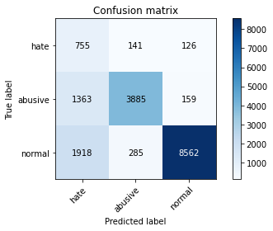

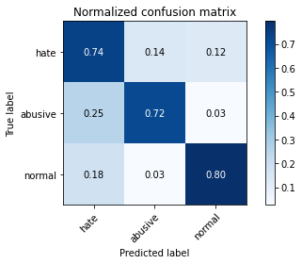

precision recall f1-score support

hate 0.19 0.74 0.30 1022

abusive 0.90 0.72 0.80 5407

normal 0.97 0.80 0.87 10765

accuracy 0.77 17194

macro avg 0.69 0.75 0.66 17194

weighted avg 0.90 0.77 0.82 17194

average eval_loss: 0.8654030154697424, accuracy: 0.7678259858090032

5 run...

training 1 epoch...

240.00550413131714 seconds used......

1 training finished! average train loss: 0.5746633229150729

evaluating...

Confusion matrix, without normalization

[[ 848 60 114]

[1983 3253 171]

[2014 142 8609]]

Normalized confusion matrix

[[0.8297456 0.05870841 0.11154599]

[0.36674681 0.60162752 0.03162567]

[0.18708778 0.0131909 0.79972132]]

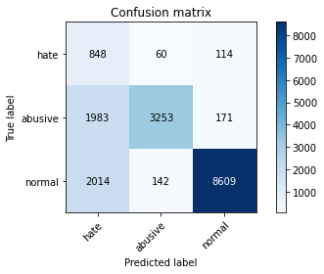

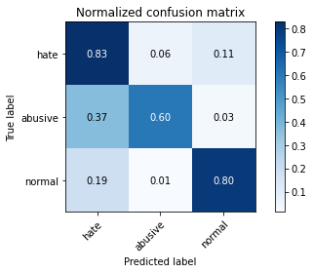

precision recall f1-score support

hate 0.18 0.83 0.29 1022

abusive 0.94 0.60 0.73 5407

normal 0.97 0.80 0.88 10765

accuracy 0.74 17194

macro avg 0.69 0.74 0.63 17194

weighted avg 0.91 0.74 0.80 17194

average eval_loss: 0.5704971875562225, accuracy: 0.7392113527974875

training 2 epoch...

240.11301183700562 seconds used......

2 training finished! average train loss: 0.41067840697130287

evaluating...

Confusion matrix, without normalization

[[ 837 57 128]

[1933 3309 165]

[1534 177 9054]]

Normalized confusion matrix

[[0.81898239 0.05577299 0.12524462]

[0.35749954 0.61198446 0.030516 ]

[0.14249884 0.01644217 0.84105899]]

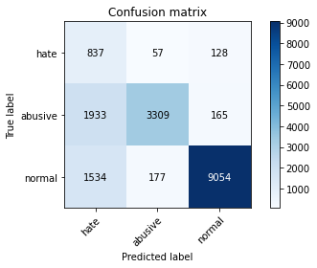

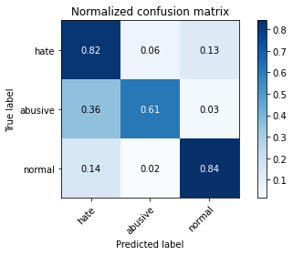

precision recall f1-score support

hate 0.19 0.82 0.31 1022

abusive 0.93 0.61 0.74 5407

normal 0.97 0.84 0.90 10765

accuracy 0.77 17194

macro avg 0.70 0.76 0.65 17194

weighted avg 0.91 0.77 0.81 17194

average eval_loss: 0.5018265164089064, accuracy: 0.7677096661626148

training 3 epoch...

240.2021667957306 seconds used......

3 training finished! average train loss: 0.286872018902283

evaluating...

Confusion matrix, without normalization

[[ 815 56 151]

[2090 3087 230]

[1360 177 9228]]

Normalized confusion matrix

[[0.79745597 0.05479452 0.14774951]

[0.38653597 0.57092658 0.04253745]

[0.12633535 0.01644217 0.85722248]]

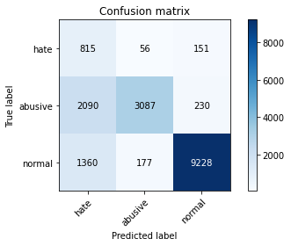

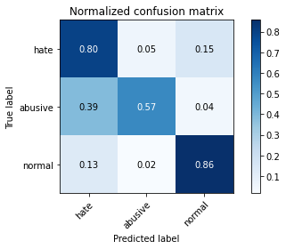

precision recall f1-score support

hate 0.19 0.80 0.31 1022

abusive 0.93 0.57 0.71 5407

normal 0.96 0.86 0.91 10765

accuracy 0.76 17194

macro avg 0.69 0.74 0.64 17194

weighted avg 0.91 0.76 0.81 17194

average eval_loss: 0.5509797720151932, accuracy: 0.7636384785390252

training 4 epoch...

240.33580327033997 seconds used......

4 training finished! average train loss: 0.1900093787755506

evaluating...

Confusion matrix, without normalization

[[ 857 80 85]

[1816 3459 132]

[2650 238 7877]]

Normalized confusion matrix

[[0.83855186 0.07827789 0.08317025]

[0.33586092 0.63972628 0.0244128 ]

[0.24616814 0.02210869 0.73172318]]

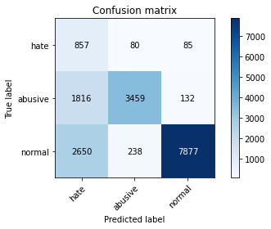

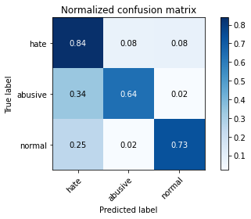

precision recall f1-score support

hate 0.16 0.84 0.27 1022

abusive 0.92 0.64 0.75 5407

normal 0.97 0.73 0.84 10765

accuracy 0.71 17194

macro avg 0.68 0.74 0.62 17194

weighted avg 0.91 0.71 0.78 17194

average eval_loss: 0.9779366074173257, accuracy: 0.7091427242061185

training 5 epoch...

240.17251014709473 seconds used......

5 training finished! average train loss: 0.1335384412521484

evaluating...

5 training finished! average train loss: 0.1335384412521484

evaluating...

Confusion matrix, without normalization

[[ 738 125 159]

[1499 3649 259]

[1410 230 9125]]

Normalized confusion matrix

[[0.7221135 0.1223092 0.1555773 ]

[0.27723322 0.67486591 0.04790087]

[0.13098003 0.02136554 0.84765444]]

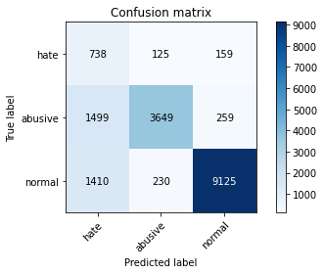

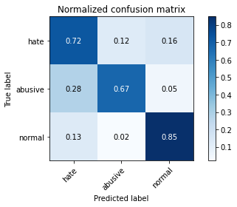

precision recall f1-score support

hate 0.20 0.72 0.32 1022

abusive 0.91 0.67 0.78 5407

normal 0.96 0.85 0.90 10765

accuracy 0.79 17194

macro avg 0.69 0.75 0.66 17194

weighted avg 0.90 0.79 0.83 17194

average eval_loss: 0.6919924984534466, accuracy: 0.7858555309991858